ELEC 5150/6150 Information Security

Project
Xiao Lin & Yuanqi Chen

Abstract
In the project we are going implement two data encryption and key transport as well as the password based data protection method. All method in this project is according to NIST recommendation.

Introduction
In the step 1, we are going to Use RSA 2048 bit to perform key transport. A large file is encrypted using GCM (AES 256-bit) and the AES key (+ IV) is wrapped and delivered using the RSA key transport. And in step 2 we are gonging to implement ECDH key transport. And in step 3 we are going to implement a password based data protection method.

Design
Step 1
Because of the length of codes is too long, so we only show the critical part of code here as well as the result.

Step1 have two parties, one is Alice and another is Bob.
In Alice there are six java file in total. Wrap.java is used to wrap AES key and IV. geneRSAKey.java is used to generate RSA key, GeneAESKeyandIV.java is used to generate AES key and IV using controlled seed, EncryptFile.java is used to encrypt file, easyscanner.java is used to get user's input. Alice.java is the main program.
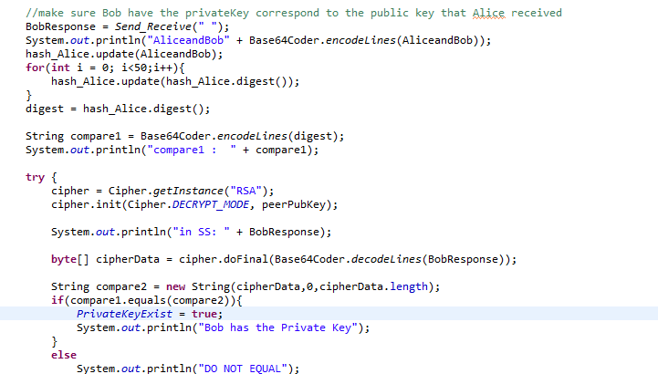
This code is in Alice.java line 186 to line 212, this part is for Alice to make sure that Bob have the correspond private key
Here is the communication between Alice and Bob
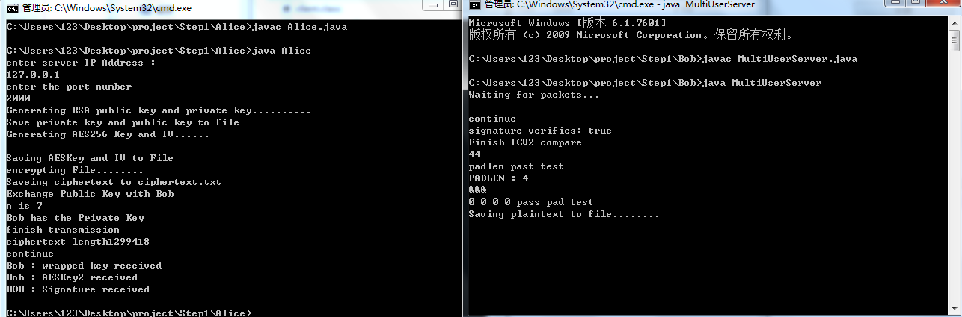

Here is the public key and private key of Alice and Bob
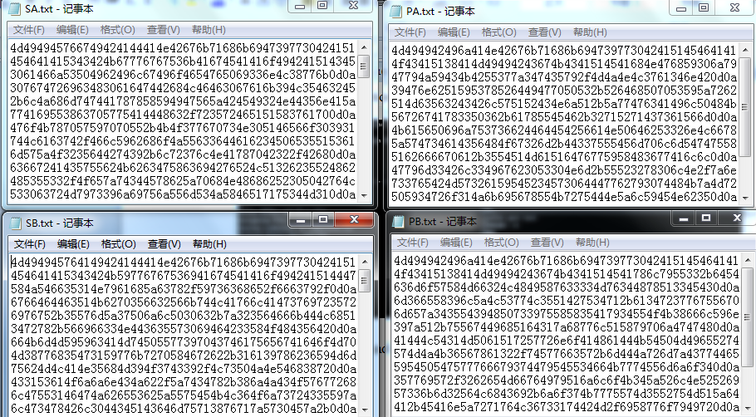
Here is the cipher text and plain text in Alice and in Bob
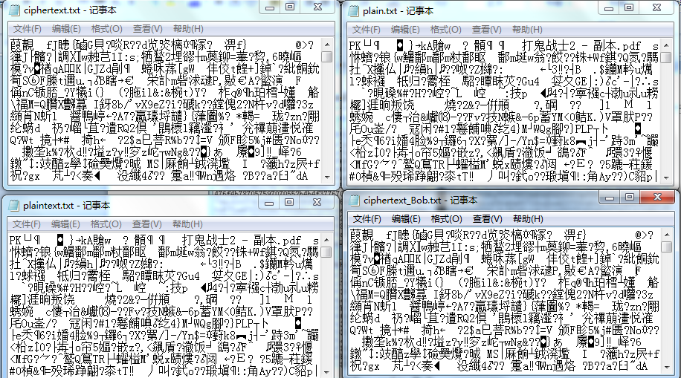
And if we change the plaintext.txt to plaintext.zip we can get a zip file and in the file is the test pdf file.

Step 2
In this step we are going to implement the ECDH key transport algorithm. In this step there are also two parties, one is Alice and another is Bob, Alice is sender and Bob is Receiver. In Alice there are 6 .java file they play the similar roles in step 1 and in Bob there are 6 .java files they also play similar roles in step 1.
Here is the transmission capture
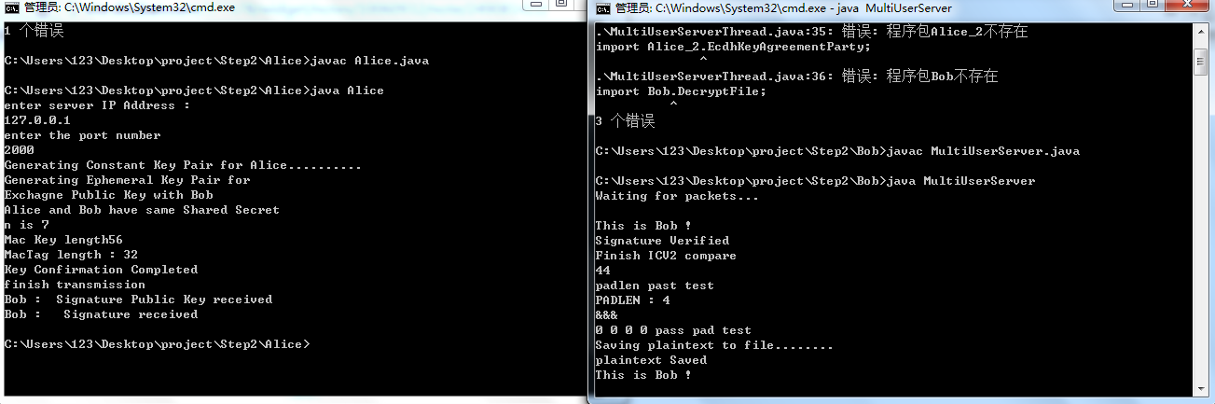
The key of Alice and Bob
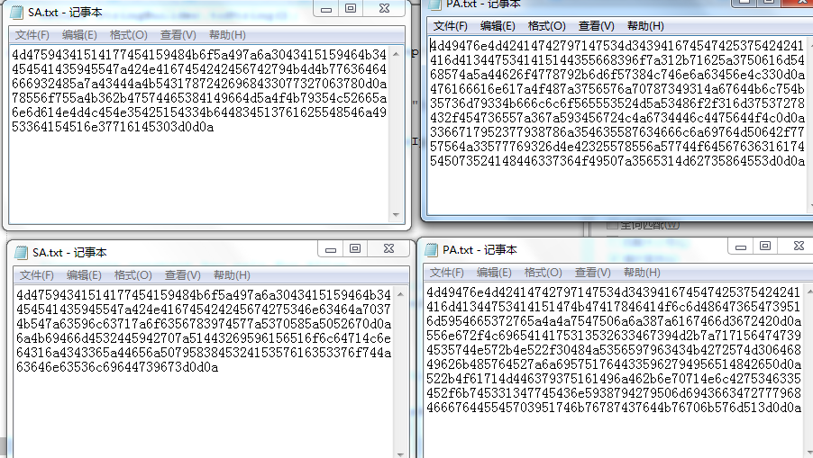
The ciphertext and plaintext in Alice and Bob
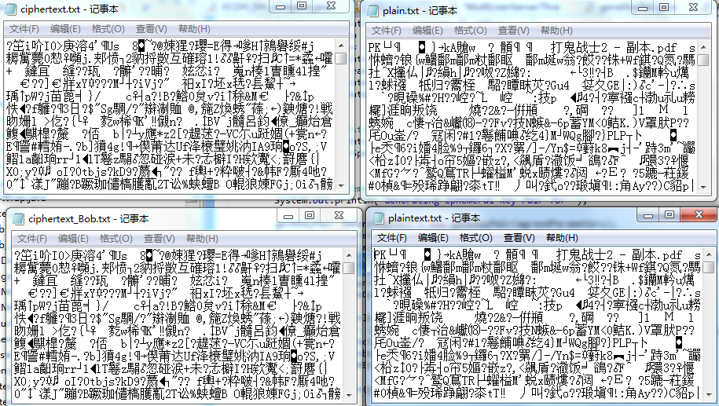
And the plaintext.txt can be renamed to plaintext.zip and unzip it we will get the pdf.
Step 3
In this step we are going to implement a password based data protection.
In this step3 there is no data transmission of different parties. And there are 10 .java file in total. Maintest_encryption2.java is for encryption and maintest_decryption2.java is for decryption.
Here is the capture for encryption and decryption
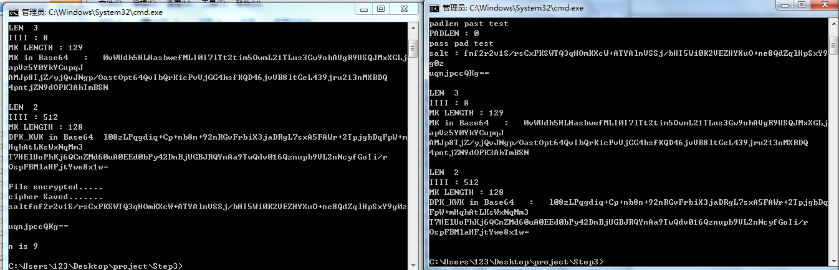

Here is the ciphertext and plaintext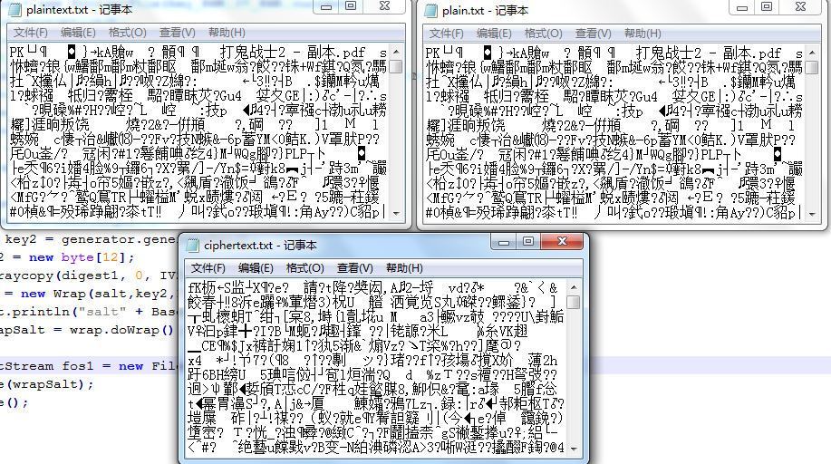

Result
All of the steps in this lab have been completed without significant problem, the project is very closely to the lab we have do previous, it enhance our understanding of the key exchange scheme and the AES/GCM encryption. The most challenge one I think in this project is the step 1 because of that we are not familiar with the NIST recommendation. But it gets better after several hours of work.

Conclusion
All of the steps have been finished. It takes a lot of work but it really a challenge for us to finish such a project and it satisfied us with the accouchement of finishing the project.

References
- Example codes and sample solutions of the Lab from Dr.Wu
- NIST Recommendation SP 800-38F,SP800-56B,SP800-56C,SP800-132

